

FACULTY OF ENGINEERING AND ARCHITECTURE DEPARTMENT OF MECHATRONICS

DESIGN AND IMPLEMENTATION

OF AN AUTOMATIC LIQUID

DOSING SYSTEM

GRADUATION/DESIGN PROJECT

in partial fulfillment of the requirements for the degree of  
BACHELOR OF SCIENCE

KADRİ EMRE ORGUN 170412056

AYBERK KILLI 180412017

HAYDAR BARIŞ ÖCAL 160412026

ÖMER YÜCE 180412036

SUPERVISOR: DR. SERKAN DOĞANAY

JANUARY 2023

DESIGN AND IMPLEMENTATION

OF AN AUTOMATIC LIQUID

DOSING SYSTEM

A GRADUATION/DESIGN PROJECT  
by

KADRİ EMRE ORGUN

AYBERK KILLI

HAYDAR BARIŞ ÖCAL

ÖMER YÜCE

submitted to the Mechatronics Engineering of

İZMİR KÂTİP ÇELEBİ UNIVERSITY

Approved by: Dr. Serkan DOĞANAY

Chair Name

(Signature)

| Member Name  (Signature) | Member Name  (Signature) |
| --- | --- |
| Member Name  (Signature) | Member Name  (Signature) |

JANUARY 2023

# ABSTRACT

The subject of our project is liquid dosing devices and liquid transfer systems at low volume levels (micro/milliliter). This subject is widely used today in microbiology, chemistry, and medical test laboratories to transfer liquids precisely and at the right rates. which is the subject of our final project. For these tests and fluid transfers, generally micropipettes are used. Although tests and transfer processes which micropipette is used are made by trained technicians, human-induced errors (incorrect dosing, sample fluid loss, incorrect force application while vacuuming) occur. These human-induced errors constitute an important part of the errors that occur in the laboratory. Also, if sample preparation is made manually, it increases the time required to complete dosing.

With these informations and data, in our project our main aim is developing an automatic liquid dosing system that provides the potential to increase the speed of liquid transfer and dosing processes for the laboratory testing field, keeping margins of error lower than today's laboratory liquid transfer and dosing systems, reducing the need for manpower and reducing human-induced errors in the laboratory.

Keywords: micro-dosing, automatic dosing, laboratory automation, sample testing

# ÖZET

Projemizin konusu olan düşük hacim seviyelerinde (mikro/mililitre) sıvı dozajlama araçları ve sıvı transferi sistemleri günümüzde mikrobiyoloji, kimya ve medikal test laboratuvarlarında sıvıların hassas şekilde ve doğru oranlarda transfer edilmesi için yaygın olarak kullanılmaktadır. Bu testler ve sıvı transferleri için genellikle mikropipetler kullanılmaktadır. Mikropipet kullanılarak yapılan testler ve transfer işlemleri her ne kadar eğitimli teknisyenler tarafından yapılıyor olsa da insan kaynaklı hatalar (yanlış oranda dozajlama, örnek sıvı kaybı, vakum yapılırken yanlış oranda kuvvet uygulanması) meydana gelmektedir. İnsan kaynaklı hatalar laboratuvarda meydana gelen hataların dikkate değer bir kısmını oluşturmaktadır. Ayrıca, el ile olarak yığınlar şeklinde numune hazırlanması durumlarında, dozajlamanın tamamlanması için gerekli zamanı artırmaktadır.

Bu bilgiler ve verilerden yola çıkılarak projemizde, laboratuvar testleri alanına yönelik sıvı transfer ve dozajlama işlemlerinin hızında artış sağlama, hata paylarının günümüz laboratuvar sıvı transfer ve dozajlama sistemlerinden daha düşük seviyede tutma, laboratuvarda insan gücüne olan ihtiyacın ve insan kaynaklı hataları azaltma potansiyeli sağlayabilecek otomatik bir sıvı dozajlama sistemi geliştirilmesi amaçlanmaktadır.

Anahtar Kelimeler: mikro dozajlama, laboratuvar otomasyonu, otomatik dozajlama, numune testleri

# ACKNOWLEDGMENTS

If appropriate, place your acknowledgment here. Otherwise, you may safely remove this page.

**TABLE OF CONTENTS**

ABSTRACT ii

ÖZET iii

ACKNOWLEDGMENTS iv

LIST OF TABLES vi

LIST OF FIGURES vii

SYMBOLS viii

ACRONYMS ix

I. INTRODUCTION 1

1.1. Motivation 1

1.2. Literature Review 1

1.3. Objectives3

II.Materials and Methods 6

2.1. Mechanical Design 6

2.1.1. 1-Dimensional Mechanical Design 6

2.1.2. 2-Dimensional Mechanism Design10

2.1.3. Syringe Changing Mechanism Design13

2.1.4. 3-Dimensional Mechanism Design16

2.1.2 Electronic Design18

2.1.3. Work Space Algorithm21

2.1.4. Theoretical Background 22

REFERENCES 27

# 

# LIST OF TABLES

# 

# LIST OF FIGURES

Figure 1:

CAD Design of the Syringe Pump Mechanism7

Figure 2: The Syringe Pump Mechanism7

Figure 3: CAD Design of the Prototype of 2D Movement Mechanism 9

Figure 4: The Prototype of 2D Movement Mechanism9

Figure 5: The Electronic Circuit Diagram for Driving a Step Motor11

Figure 6: The Schematic of Work Area13

# 

# SYMBOLS

***α*** Alpha

***β*** Beta

***γ*** Gamma

# ACRONYMS

**1D** 1-Dimensional

**2D** 2-Dimensional

**3D** 3-Dimensional

# INTRODUCTION

## 1.1. Motivation

In the 21st century, progress and development of technology continue with time. With this, the need for small-scale engineering systems and processes is even more stand out [1]. One of the most important required small-scale engineering systems and processes is test applications on samples applied in medical laboratories [2]. Although medical engineering systems have an important area of use these days, there are points which open to development for these systems with developing technology [3]. One of the most important points for improvement in sample testing applications is precise sample dosing with using injectors [4].

## 1.2. Literature Review

Mukherjee and friends [5] developed a system to measure syringe injection rates with using two “Hall-effect” sensors. With using an annular magnet and “Hall-effect” sensors placed on the outside of the syringe (in the same direction with the piston), a linear relationship was established between the output voltage generated by the displacement of the magnet and liquid coming from the injector tip. Dosage measurements in this system were made in microliter level. This system is suitable for the area of improving education on injection application procedures.

Streule and friends [6] developed a dosing system called “Pipe-jet” with using a metal jaw structure (which is placed parallelly) that can be squeezed towards each other with help of a “piezo stack” actuator and a polymer pipe with 200 µm inner diameter. Dosage measurements in this system which works with nozzle structure were made at the microliter level. This system is suitable for use in medical and biological laboratory applications.

Sahay and friends [7] developed a computer-controlled system with a feedback structure with using “Inkjet dispensing” infrastructure. In this system, liquid coming out of the “micro-dispensing” unit is dosed with feedback with using a CCD line scanning camera and weight measurement module. This system provides dosing in microliter and milliliter levels. This system has been developed for use in drug filling lines and drug production dosing applications.

Lee and friends [8] developed a system that can dosing with linear motion control by using a microcontroller, motor driver, and stepper motor. The micropipette is used for the dosing process in this system. With controlling the motor step according to the desired size, the dosing process is done. This system provides dosing at the microliter level. This system is suitable for one-dimensional dosing for non-repetitive processes where speed is not required.

Jafarzadeh and friends [9] developed a system in which they can control the amount of dosing by using stepper motor and based on time skip in one step. The system can inject 1 cc of liquid or medicine in 6 seconds. This system provides dosing at the milliliter level. This system is suitable for blood transfusion applications for patients who cannot take their medication orally.

Amarante and friends [10] developed a suitable dosing mechanism for 30 ml and 60 ml syringes using Nema 17 stepper motor and a “Teensy” microcontroller. They dosed 1.24 µl of liquid in one motor step for a 30 ml syringe and 1.88 µl of liquid in one motor step for a 60 ml syringe. This system is suitable for applications in behavioral neuroscience laboratories.

Lake and friends [11] developed a low-cost mechanism using Arduino, syringe pump, pressure sensor, amplifier, and motor driver. In this mechanism, PID and Bang-Bang controller are used to control the pressure-driven flows inside the microfluidic chips. This system can be used in many different research areas because pressure-driven microfluidics covers a wide variety of disciplines.

Carvalho and friends [12] developed “OSMAR”, an open-source auto-sampler mechanism with G-code control. This mechanism is controlled by free “Autolt” automation software using Nema 17 stepper motors. This system provides dosing at microliter level (4 µL, 6 µL, 8 µL). This system is suitable for use in chemistry and biochemistry laboratory applications.

Samokhin and friends [13] developed a mechanism that used Arduino as the controller for the syringe pump system and they preferred to use an LCD keypad to make any settings changes and operating mode selection on the device. In this mechanism, they used a 10 mL glass syringe (Kloehn) to evaluate to analytical properties at 1 mL and 5 mL scales.

Florian and friends [14] developed OTTO, an automated 3D movable micropipette system controlled by Arduino, with using a micropipette, stepper motor, and motor driver. With using a micropipette, this system provides dosing at the microliter level. This system is suitable for sample testing applications in hospitals and laboratories.

Cañas and friends [15] developed an automated robotic workflow for performing SARS-CoV-2 RT-PCR tests using OT-2 robots and other commercial systems, as well as validating its viability at the production level. In this system, have processed over 40,000 samples in more than 500 runs. OT-2 robots were created to perform simple pipetting tasks in research laboratories.

Barthels and friends [16] developed FINDUS, a fully integrable noncommercial dispensing utility system, to automatize repetitive liquid-handling tasks in a modern life science laboratory. The basis for the liquid transfer machinery was a commercially available micropipette integrated with a displacement piston. This system is suited for several showcase applications from both the biology and chemistry fields.

Steffens and friends [17] developed a simple and low-cost, versatile pipetting robot constructed partly using open-source hardware that can be used for online monitoring of water quality. The standard pipetting volume of this system was set to 1 mL per channel. This system is suitable for application in online monitoring of drinking or surface water monitoring.

Darling and friends [18] developed a syringe pump extruder and curing system (SPECS) that is capable of using multiple syringe volumes and needle sizes that can be quickly and easily change. This system provided includes 3D printed holders for 5 ml and 60 ml syringe volumes so it is possible to test small volumes of material and scale this volume up. This system is suitable to use in laboratories pursuing material developments in the area of additive manufacturing.

Tashman and friends [19] developed an open-source syringe pump for extrusion-based 3D bioprinting of soft materials: “the Replistruder 4”. They used a 2.5 mL Hamilton gastight syringe for this project. This system is suitable to use 3D bioprinting.

After the literature review presented above is analyzed, the main problems encountered in the proposed research area can be listed as follows:

(i) In current studies, they generally use micropipettes as the mechanism for fluid transfer. For this reason, the dosing amount and error of the system in one step are limited by the error rates in the manual use of the micropipette.

(ii) They generally use micropipettes for liquid transfer, but if the liquid transfer process is not carried out within a certain time and speed with micropipettes, there might be air entry into the micropipette and therefore incorrect dosing situations occur.

(iii) In current studies, the level of immersion of the syringe into the sample container do not be controlled, and that may cause air entry into the syringe or micropipette during sampling.

## 1.3. Objectives

The aim of our project is, designing and activating an automatic liquid dosing system that makes enables a syringe injector to do precise dosing while moving between different test containers in an automated and 3D cartesian coordinate system and changing syringes when different samples are required to be dosed.

After we analyzed the literature review and problems presented in “1.2. Literature Review”, providing sensitive liquid transfer even at microliter level with low dosing errors by using a fixed flat needle-tipped glass chromatography injector with low dead volume, is the aim for our automatic liquid dosing system, which for providing solutions to the main problems encountered and to be overcome in the research area we are working on.

In this direction, our objectives for our final project are as follows:

* Design of a one-dimensional mechanism that can takes or doses all or a defined amount of the liquid in the syringe a by using Nema 14 stepper motor.
* Design and development of the mechanism that enables the system to work in 2D without any delay and error.
* Design and development of a platform to exchange syringes with a syringe pump in the working area.
* Design and development of the mechanism that enables the system to work in 3D with montaging 2D and 1D mechanisms.
* Creating and activating the necessary algorithm and work plan for the system to become fully automated.

# Materials and Methods

## 2.1. Mechanical Design

The design of the automatic liquid dosing machine consists of 4 main steps. These steps are described below:

### 2.1.1. 1-Dimensional Mechanism Design

The first of these steps is designing and developing a mechanism that is able to move in a 1-Dimensional plane. In this step, our aim was designing a syringe pump mechanism that is suitable for the following steps. This mechanism cam be able to take liquid from sample containers with a defined amount and dose this liquid fully or desired amount. This process carried out with Arduino code that we wrote and develop, and with using a motor driver and step motor.

#### Prototype 1-D Mechanism

In this system, we used a Nema 14 Stepper Motor, a micro stepper motor driver, flexible coupling, ball screw, a precision syringe, induction hard chrome plated shaft, linear bearing, ball bearing, shaft fastener, step motor connection plate, trapezoidal ball screw nut and 3D printed plastic parts.

The Nema 14 stepper motor we used has 200 steps and the micro stepper motor driver can divide steps by 1/32. So, the stepper motor makes one revolution for every 32x200=6400 step entered in the code. Therefore, for each step value entered in the code, the system rotates 360°/6400=0.056°. The pitch of the ball screw is 2 mm. In this case, the system moves 2 mm for each revolution (6400 steps). The change in the linear position of the syringe piston with each step entered will be 2 mm/6400=0.3125 µm. We set Arduino code that each step takes place within 40 µs, so the time taken for the system to complete one revolution is 40 µsx6400 = 0.256 s.

2 mm linear position change for our system takes 0.256 s, then the piston velocity should be 7.8125 mm/s.

The prototype, one-dimensional syringe pump mechanism was prepared and simulated as shown in Figure 1 and Figure 2 below.

Araba parçası, makine, çelik, boru, tüp içeren bir resim

Açıklama otomatik olarak oluşturuldu

###### *Figure 2.1.1.1 : CAD Design of the Prototype* makine, alet içeren bir resim Açıklama otomatik olarak oluşturuldu

###### *Figure 2.1.1.2 : The Prototype*

We tested this prototype mechanism with rotating Nema 14 stepper motor 5 times. It makes 6400x5=32000 steps. The pitch of the ball screw is 2 mm, so for 5 rev, 2 mmx5= 10 mm. We made these tests with using a 1 ml plastic syringe, which has 4.40 mm inner diameter. Then the cross-sectional area of this syringe is 3.14x4.40 mmx4.40 mm=15.205 mm^2. For 5 rev, volume change should be 15.205 mm^2x10 mm=152.05 mm^3 theoretically. After these tests, the mean of 6 volume change results is 0.1572 mg (157.2 mm^3) by precise weighing machine. Percentage error for volume change according to mean volume change is %1.40.

After making tests with our prototype, we designed our final mechanism step by step.

makine içeren bir resim

Açıklama otomatik olarak oluşturuldu

###### *Figure 2.1.1.3 : The Syringe Pump Mechanism*

We used a Nema14 stepper motor [1] to drive the syringe plunger. To transfer power to the lead screw shaft, we used a rigid coupling [2]. The purpose of using a rigid coupling is to transfer the movement of the stepper motor to the lead screw with minimal loss. The lead screw shaft [3] is used in conjunction with the trapezoidal nuts [11] to transfer circular motion to linear motion. For a more precise linear motion, we chose a 2mm pitch, 8mm diameter lead screw shaft. To prevent momentum forces that may occur in different axes along the linear motion, we used a chrome-plated induction shaft (6mm) [4]. We used a KFL08 flange bearing [5] to secure the lead screw shaft to the yellow body seen in the picture. To prevent the syringe holder from separating from the body, we used an electromagnet [6] with a 3kg pulling force. To facilitate the placement of the syringe holder in the body and make its movement more difficult, we placed a geometric constraint under the electromagnet. After the syringe holder is placed in the body, we used two electromagnets [7] with a 45-degree angle to prevent the up-and-down movements in the z-axis caused by the piston movement. Each electromagnet has a holding force of 8kg.

ekran görüntüsü, çizgi film, mor içeren bir resim

Açıklama otomatik olarak oluşturuldu

###### *Figure 2.1.1.4 : The Syringe Pump Mechanism*

We used linear bearings [9] to provide movement along the chrome-plated shafts. To control movement of the syringe piston head at desired intervals, we used an electromagnet [10] with a force of 3kg. To ensure that these parts stay stable in the same plane, we designed a piston compressor body [8] that was lightweight and took up minimal space.

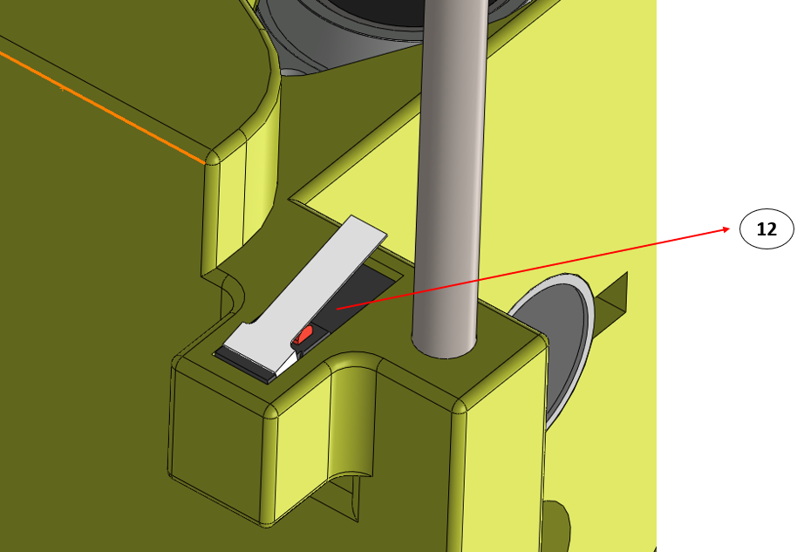

###### *Figure 2.1.1.5 : The Syringe Pump Mechanism*

To prevent damage to the syringe and other mechanical parts, we limited the movement of the piston compressor body using microswitches [12].

### 2.1.2. 2-Dimensional Mechanism Design

Our mechanism's chassis was constructed using 8 pieces of 50 cm long 30x30 mm sigma profile and 6 pieces of 60 cm long 12 mm chromed round bars. The mechanism parts, which were printed from a 3D printer, were assembled using the sigma profiles and chromed round bars to create a 2D mechanism that can stand upright.

öğütme makinesi içeren bir resim

Açıklama otomatik olarak oluşturuldu

###### *Figure 2.1.2.1: 2-Dimensional Mechanism*

###### 

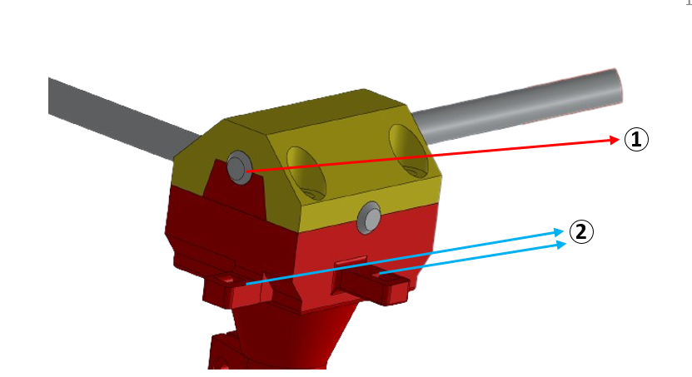

###### *Figure 2.1.2.2: 2-Dimensional Mechanism*

We designed the mechanism with a structure that can wrap the corners of the shafts in a semi-circular shape [1] and be fixed from both the top and bottom. We designed a structure [2] on top of the part that forms the bottom of the corner, where 6mm belts can be attached. We fixed the top and bottom parts together with 8mm bolts. We designed the bottom part of the component to be suitable with sigma profiles.

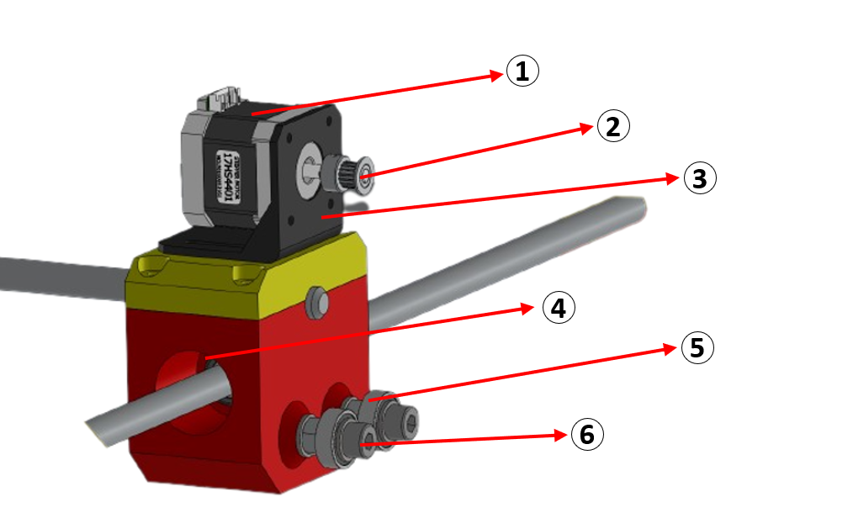

###### *Figure 2.1.2.3.: 2-Dimensional Mechanism*

To provide 2D movement, 4 Nema 17 stepper motors [1] were used. To fix the motor, we used its own bracket [3] and bolted it onto the 3D printed parts. We mounted the LM12UU linear bearing [4] onto the 3D printed part to enable movement along the shafts. A belt drive system [2,5] was installed and connected to the Nema 17 motors to provide movement in the X or Y direction of the mechanism. To enable the movement on x and y axis, we fixed the inner ring of the 608 2RS bearing [5] and used the outer ring for the movement. To control the movement, we attached a GT2 timing belt pulley [2] to the end of the Nema 17 stepper motor. We used an M8 bolt, pulley, and nut [6] to ensure that the timing belt pulley and the bearings were in the same plane.

To test the stability of the system, we adapted the electronic components that we used in our previous 1-dimensional prototype mechanism to fit our new mechanism. To do this, we connected the poles of two Nema 17 motors facing in opposite directions in reverse. After performing the necessary tests, 4 pieces of 50 cm long support sigma profiles were placed on the bottom of the mechanism to ensure that it stands more stably. These were fixed with corner connection elements.

The 2D mechanism was prepared and simulated as shown in Figure 3 and Figure 4 below.

###### *Figure 2.1.2.3: CAD Design of the Prototype of 2D Movement Mechanism* metin, gök, açık hava, ışık içeren bir resim Açıklama otomatik olarak oluşturuldu

### 2.1.3. Syringe Changing Mechanism Design

In this project, our 3D automatic liquid dosing system works with more than one type of liquid sample. Therefore, the syringe interacts with different liquid samples. For this reason, it is possible that the remaining liquid from the first sample taken into the syringe and the liquids to be taken later will mix with each other and affect our system negatively. So, we thought a possible solution for this problem.

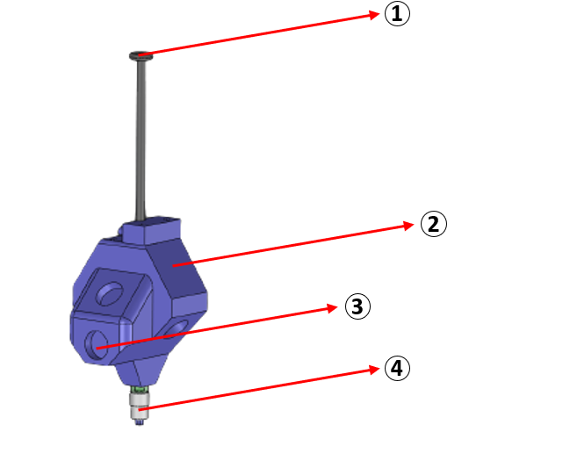

###### *Figure 2.1.3.1: Syringe Holder Mechanism*

The solution that we used is, using different syringes for each different sample fluid. Syringes used as many as the number of different sample liquids. Due to the high level of precision required for replacing the syringe only, we designed a syringe holder [2] where each syringe is manually mounted by an operator before the dosage process. To ensure that the syringe holder could remain on the movable and stationary system at desired time intervals, we used magnetizable 420 stainless steel [3] on top of the syringe holder. We mounted them onto the syringe holder. For the dosage process, we designed the holder to leave the tip of the syringe [4] exposed and not block the movement of the plunger [1].

ekran görüntüsü içeren bir resim

Açıklama otomatik olarak oluşturuldu

###### *Figure 2.1.3.2: Syringe Holder Mechanism*

We designed a part [1] that would fix the finger flange [2] to the syringe holder to prevent the movement of the syringe body in the z-axis. To make easy the transfer of the holder to the dosing unit and prevent unwanted movement in different directions, we designed a geometric constraint [3].

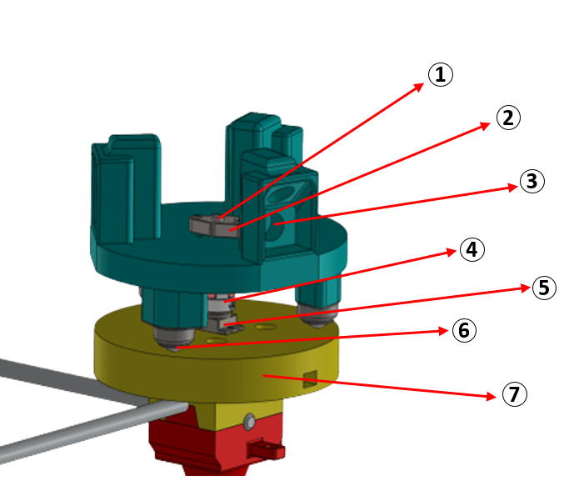

###### *Figure 2.1.3.1: Syringe Changing Mechanism*

We designed a syringe changing mechanism for changing syringes in process. We designed the mechanism with a stationary lower part [7] that would hold the shafts, and a movable upper part that could be controlled with a servo motor [5]. We used an 8mm shaft [1] to make both parts to be mounted concentrically. We used an SKF 08 shaft end holder [2] to fix the shaft and enable it to rotate with the movable part. We used a rigid coupling [4] to transfer the motor movement precisely and without loss to the shaft. We used ball caster wheels [6] with 120-degree intervals on the upper part to take the load off the motor and create more balanced movement. We used permanent magnets [3] to keep the syringe slots fixed on the mechanism when the system is de-energized.

### 2.1.4. 3-Dimensional Mechanism Design

The final step of the 3D mechanism is combining the 2D mechanism and 1D syringe pump mechanism to allow 3-Dimensional motion. For this 3D automatic liquid dosing machine, the motion system of 3D printers is taken as an example. After the montage, our mechanism can able to take sample liquid from coordinates which taken by user input on the computer, and dose this liquid in desired amount into to test liquid containers, by the same way. For 3D motion, except for controlling the motion of the syringe piston and syringe changing mechanism, we used 5 Nema 17 stepper motors. 2 motors for each x-axis and y-axis, and 1 motor for the z-axis.

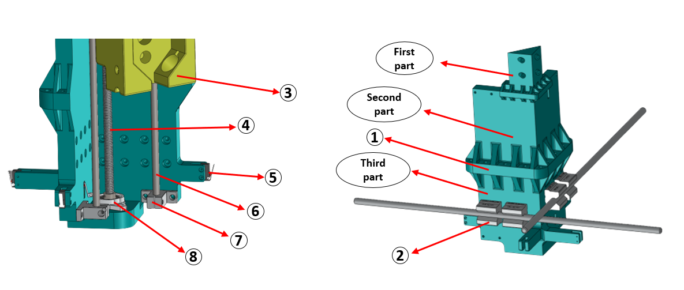

###### *Figure 2.1.4.1: 3-Dimensional Mechanism*

We designed a structure that will hold one-dimensional syringe compressing mechanism [3], motors and other mechanical parts, and also provide coordination of movement in the x and y axes. We separated this part into three sub-parts as seen in the image above to make it easier for producing and if there will any damage on one of these parts, replace lesser parts. To tightly connect the parts to each other and reduce the possibility of breakage at connection points, we designed a flanged and federated connection element [1]. We used an SBR 12UU open block linear bearing [2] for the movement of the third part on shaft that provides movement on the x- y axes. We fixed the third part to these open block linear bearings with bolts. For the z-axis movement of the one-dimensional syringe compressing mechanism, we used a linear motion system that contains a threaded rod [4] and chrome-plated rod [6] that we previously used. We used a KFL 000 flange bearing [8] to fix the threaded rod and an SK10 linear shaft support [7] to fix the chrome-plated rod. To ensure that the mechanism consisting of three parts stays inside of the determined workspace and can reset for various sub-processes, we used 4 straight lever microswitches [5] facing in opposite directions on both axes.

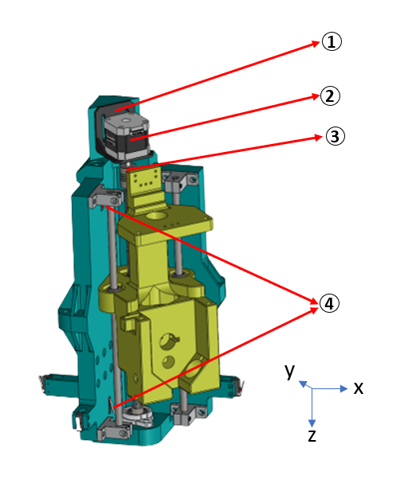

*Figure 2.1.4.2: 3-Dimensional Mechanism*

We used a Nema 17 step motor [2] for the z-axis movement of the single-axis syringe mechanism. We fixed the motor to the first part using a Nema 17 motor bracket [1]. To dampen small axial movements between the axis of the motor end and the axis of the threaded rod, making power transmission efficiently, we used a flexible coupling [3]. To limit the z-axis movement of the single-axis syringe mechanism for various processes and also to prevent potential damages caused by incorrect movement of the motor, we used a roller lever microswitch [4].

## 2.2. Electronic Design

2 tane x ekseni için, 2 tane y ekseni için, 2 tane z ekseni için, 2 tane de syringe piston compressor için limit switch kullandık. Syringe holder için 3 tane 12v luk electromagnet kullandık. bağlantılarını yaptık.

Ramps pinleri yazılacak.

Opsiyonel olarak bağlantı şeması çizilebilir.

Ramps fotoğrafı silinecek ve güncellenecek.

Kodlar en alta eklenecek.

Servo sorunu çözülecek ve hakkında behsedilecek.

Kabloları birbirleri ile bağladık

In our system, motion is provided by step motors and a motor driver which driven by Arduino. We used 7 motors for the 3D liquid dosing mechanism. 2 for the 1D mechanism, 4 for the 2D mechanism, and 1 for the syringe changing mechanism. We run these mechanisms with 1 Arduino Mega microcontroller which combined with Ramps 1.4 hardware controller. It has 5 step motor driver part and 6 step motor connection part, 1 for x-axis, 1 for y-axis, 2 for z-axis and 2 for extruders. We will also connect switches to control borders of our 2D and 1D mechanisms. We used this Ramps 1.4 for driving 6 stepper motors which for controlling mechanism with 2 Nema17 for x-axis, 2 Nema17 for y-axis, 1 Nema17 for z-axis and 1 Nema14 for syringe pumping in z-axis. For syringe changing mechanism, we used MG996R servo motor.

The electronic circuit diagram for trying to drive the stepper motor is shown in figure below;

###### *Figure 2.2.1: The Electronic Circuit Diagram for Driving a Step Motor*

By connecting the A+ A- and B+ B- poles in the motor driver in opposite directions, we ensured that the parallel motors we used for 2-dimensional motion move in the same direction. We have determined that 1.5 amps are required for a single motor and 1.8 amps for a double motor to ensure this movement.

We drove the single motor using this wiring diagram. After we tried the stepper motors we will use on each axis one by one through the microstep driver, we combined the arduino with the Ramps 1.4 module in order to drive all the motors at the same time. We drived our stepper motors using 5 DRV8825 stepper motor drivers on Ramps 1.4.

We wrote the software we need to use to move our mechanism by arduino ourselves.In order to write this code, we learned which pins of the arduino correspond to which pins on the ramps 1.4. Accordingly, the equivalent of the pins on the ramps on the arduino is,

Y_STEP_PIN = 60 ;

Y_DIR_PIN = 61 ;

Y_ENABLE_PIN = 56 ;

X_STEP_PIN = 54 ;

X_DIR_PIN = 55 ;

X_ENABLE_PIN = 38 ;

Z_STEP_PIN = 46 ;

Z_DIR_PIN = 48 ;

Z_ENABLE_PIN = 62 ;

E0_STEP_PIN = 26 ;

E0_DIR_PIN = 28 ;

E0_ENABLE_PIN = 24 ;

Y_MIN_PIN = 14 ;

Y_MAX_PIN = 15 ;

X_MIN_PIN = 3 ;

X_MAX_PIN = 2 ;

Z_MIN_PIN = 18 ;

Z_MAX_PIN = 19 ;

E_MIN_PIN = 0 ;

E_MAX_PIN = 1 ;

eight_KG_MAGNETS = 10 ;

thee_KG_MAGNET = 9 ; //24V

PISTON_MAGNET = 8 ; //24V

We used 4 electromagnets to hold the syringe in our system. Since we powered the Ramps 1.4 with 12 volts, we connected two electromagnets that operate with 12V to each other and connected them to pin 10. The other two electromagnets that operate with 24 volts were connected using a voltage booster to increase the 12 volts we obtained from the Ramps to 24 volts. Since we need to use these two magnets at different times, we connected one to pin 9 and the other to pin 8.

We used the wiring diagram below.

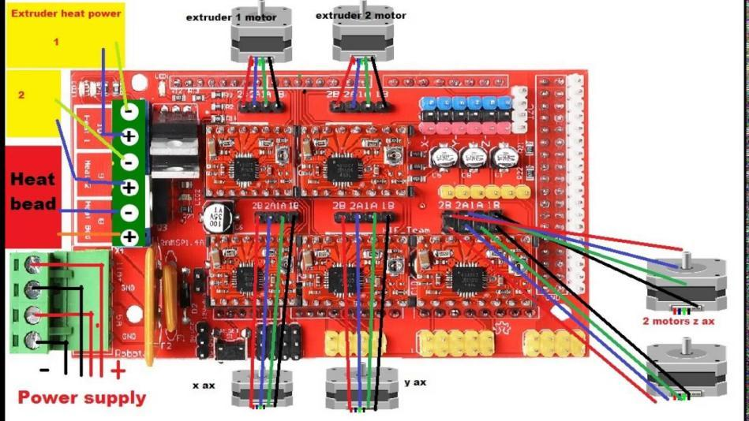

###### *Figure 2.2.2: The Electronic Circuit Diagram for Ramps 1.4*

We used each DRV8825 stepper motor driver with 32 steps. Since we used two motors for the X and Y axes movements, we connected the motors in reverse to each other and drove the two motors with a single driver. We used two 5V-powered fans to prevent the motor drivers from overheating.

## 2.3. Work Space Algorithm

After some research about liquid sampling and dosing at laboratories, we decided to use 3 different samples for our sampling area design. For example, for COVID 19 PCR test, there are 4 different samples except target DNA or RNA, which are collected using a nasal swab. These samples are PCR primers, Nucleotides, PCR buffer and Taq polymerase [20].

With our 3D automatic liquid dosing machine, different samples will be taken in desired amount into the syringe. The liquid taking process will work with sample container number and liquid volume determined by user input on the computer. Then, the liquids taken from sample containers will be dosed into different test liquid containers to form the test liquid, which will be determined by user input on the computer.

We left right area empty for syringe changing mechanisms workplace.

The schematic representation of the work area is given Figure below:

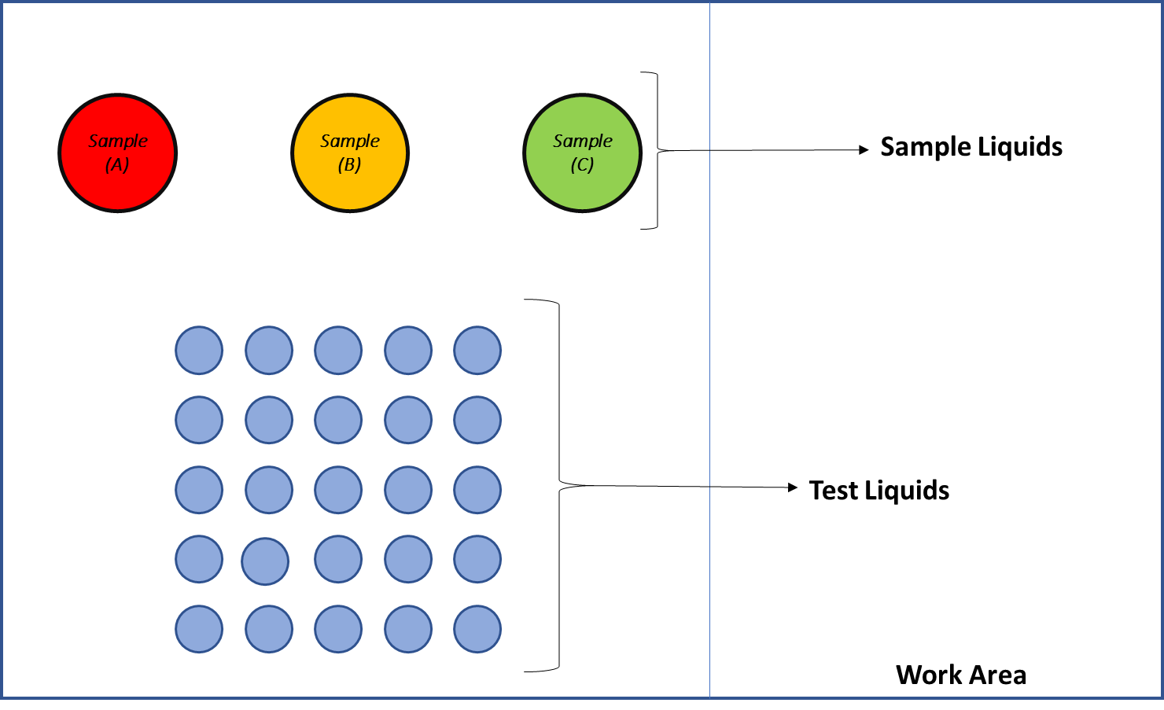

###### *Figure 2.3.1: The Schematic of Work Area*

## 2.4. Theoretical Background

We used Bernoulli’s Equation to calculate motor torque which helps us to choose acceptable step motor for our project. After these calculations, we decided to use Nema 14 stepper motor for 1-D dosing mechanism.

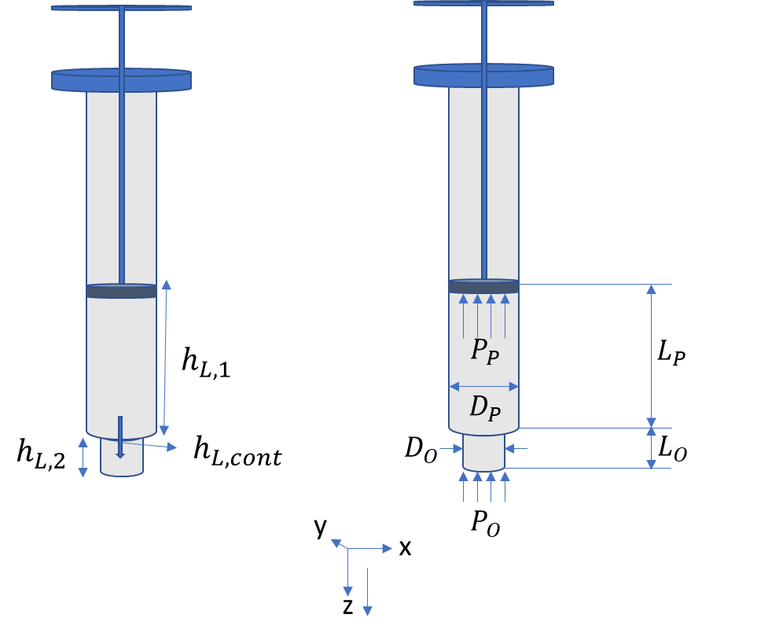

###### *Figure 2.4.1: Schematic of the Syringe*

As we can see the Bernoulli’s Equations below, we separate the piston pressure ( ) alone to decide motor torque from this result.

In these equations, means pressure at piston, means open air pressure, means velocity at piston, means velocity at needle tip, means elevation difference between two points, means density of the liquid, means gravitational constant, means head (fictional) loss along syringe, means head (frictional) loss along needle, means head (frictional) loss for contraction.

To simplify the equation, we used conservation of mass flow rate () in syringe due to law of conservation of mass. Density of liquid is constant so, as we can see below, volume flow rate () at both point is equal.

In these equations, means volume flow rate at piston, means volume flow rate at needle, means area of piston, means area of needle, means mass flow rate.

Then we separate the velocity at piston () from the velocity at the tip () to leave velocity at the tip alone. Because we know velocity at piston from the piston velocity. So, we want to make all velocity indeterminates same as .

After making these simplifications, we calculated head (frictional) losses for the system. Head loss along the syringe is , head loss along the needle is and head loss for contraction between syringe and needle is . We opened these formulas as you can see below.

In these equations, means length of syringe way, means length of needle way, means diameter of syringe, means diameter of needle, means moody friction factor, means Reynolds number, means kinematic viscosity, means head loss coefficient.

After all, we changed all values with its equal.

Final equation is shown below:

# CONCLUSION

summaryi sildim buraya sadece suan neleri gerçekleştirdiğimizi yazıp atıcaz fazla kasmaya gerek yok esas kasılması gereken durum sunum.

cunku bu raporu sadece bizim hoca görecek ama sunumu butun herkes görecek.

# REFERENCES

**[1] Bramsiepe, C., Sievers, S., Seifert, T., Stefanidis, G. D., Vlachos, D. G., Schnitzer, H., ... & Schembecker, G. (2012). Low-cost small scale processing technologies for production applications in various environments—Mass produced factories. Chemical Engineering and Processing: Process Intensification, 51, 32-52.**

**[2] Küme, T., Karakükcü, Ç., Uzun, N. K., & Pınar, A. (2016). Tıbbi Laboratuvarlarda Madde Analizleri. Türk Klinik Biyokimya Derg, 14(1), 58-71.**

**[3] Martin, R., & Barnhart, S. (2011). Global laboratory systems development: needs and approaches. Infectious Disease Clinics, 25(3), 677-691.**

**[4] He, Y., Xie, T., Tu, Q., & Tong, Y. (2022). Importance of sample input volume for accurate SARS-CoV-2 qPCR testing. Analytica chimica acta, 1199, 339585.**

**[5] Mukherjee, B., George, B., & Sivaprakasam, M. (2013, July). A syringe injection rate detector employing a dual Hall-effect sensor configuration. In 2013 35th Annual International Conference of the IEEE Engineering in Medicine and Biology Society (EMBC) (pp. 4734-4737). IEEE.**

**[6] Streule, W., Lindemann, T., Birkle, G., Zengerle, R., & Koltay, P. (2004). PipeJet: a simple disposable dispenser for the nano-and microliter range. JALA: Journal of the Association for Laboratory Automation, 9(5), 300-306.**

**[7] Sahay, A., Brown, M., Muzzio, F., & Takhistov, P. (2013). Automated drop-on-demand system with real-time gravimetric control for precise dosage formulation. Journal of laboratory automation, 18(2), 152-160.**

**[8] Lee, E., Kim, B., & Choi, S. (2019). An open-source programmable smart pipette for portable cell separation and counting. RSC advances, 9(71), 41877-41885.**

**[9] Jafarzadeh, M., & Farokhi, F. (2016). Design and construction of an automatic syringe injection pump. Pacific Science Review A: Natural Science and Engineering, 18(2), 132-137.**

**[10] Amarante, L. M., Newport, J., Mitchell, M., Wilson, J., & Laubach, M. (2019). An open source syringe pump controller for fluid delivery of multiple volumes. eneuro, 6(5).**

**[11] Lake, J. R., Heyde, K. C., & Ruder, W. C. (2017). Low-cost feedback-controlled syringe pressure pumps for microfluidics applications. PLoS One, 12(4), e0175089.**

**[12] Carvalho, M. C., & Murray, R. H. (2018). Osmar, the open-source microsyringe autosampler. HardwareX, 3, 10-38.**

**[13] Samokhin, A. S. (2020). Syringe pump created using 3D printing technology and arduino platform. Journal of Analytical Chemistry, 75(3), 416-421.**

**[14] Florian, D. C., Odziomek, M., Ock, C. L., Chen, H., & Guelcher, S. A. (2020). Principles of computer-controlled linear motion applied to an open-source affordable liquid handler for automated micropipetting. Scientific reports, 10(1), 1-10.**

**[15] Villanueva-Cañas, J. L., Gonzalez-Roca, E., Gastaminza Unanue, A., Titos, E., Martínez Yoldi, M. J., Vergara Gómez, A., & Puig-Butillé, J. A. (2021). Implementation of an open-source robotic platform for SARS-CoV-2 testing by real-time RT-PCR. PloS one, 16(7), e0252509.**

**[16] Barthels, F., Barthels, U., Schwickert, M., & Schirmeister, T. (2020). FINDUS: an open-source 3D printable liquid-handling workstation for laboratory automation in life sciences. SLAS TECHNOLOGY: Translating Life Sciences Innovation, 25(2), 190-199.**

**[17] Steffens, S., Nüßer, L., Seiler, T. B., Ruchter, N., Schumann, M., Döring, R., ... & Brinkmann, M. (2017). A versatile and low-cost open source pipetting robot for automation of toxicological and ecotoxicological bioassays. PLoS One, 12(6), e0179636.**

**[18] Darling, C., & Smith, D. A. (2021). Syringe pump extruder and curing system for 3D printing of photopolymers. HardwareX, 9, e00175.**

**[19] Tashman, J. W., Shiwarski, D. J., & Feinberg, A. W. (2021). A high performance open-source syringe extruder optimized for extrusion and retraction during FRESH 3D bioprinting. HardwareX, 9, e00170.**

**[20] https://www.soci.org/action-against-covid-19/chemistry-and-covid-19/the-chemistry-of-the-antigen-test**